Hungry Alligator (Greater Than)
Basics:
Name: Justine Van Koevering Time Allotted:
Grade Level: Kindergarten Subject(s): Mathematics
Intentional Room Set Up:
Materials Required:
- Brainzy Games. (2014). Number gators (greater than, less than symbols song) [Video]. YouTube. Retrieved from
https://www.youtube.com/watch?v=M6Efzu2slaI
- Fastener brads – one per student
- Alligator Spinner
- Hungry Alligator Worksheet
- Hungry Alligator Rubric

Michigan Content Expectations:
K.CC.6
Identify whether the number of objects in one group is greater than, less than, or equal to the number of objects in another group, e.g., by using matching and counting strategies. (Include groups with up to ten objects.)
Objective(s): A specific, measurable portion of a GLCE, CCSS, or NGSS (may more clearly state with Bloom’s taxonomy verb) including the level of proficiency.
- Objective 1: The student will identify whether the number of objects in one group is greater than the number of objects in another group reaching proficiency by scoring a 3/5 on the Hungry Alligator Rubric.
Assessment &Data & Intervention:
- Objective 1 Formal Formative Assessment: Alligator Spinner Game
The students will play the Alligator Spinner Game with a partner. They will each spin a spinner and write whichever number their spinner landed on in the blanks on the corresponding worksheet. They will then decide together which number is greater and write the greater than or less than symbol with the ‘alligator mouth’ opening up to the larger number. If the numbers are equal, they will write an equals sign. (They will have learned the equals sign from previous lessons.)
  - Data & Intervention Plan:
The teacher will walk around the room and make notes on how the students are doing. The teacher will create heterogeneous groups so that the students have more opportunities to teach and learn from each other. The teacher will be accessible and available during this activity. The students may ask any questions and the teacher will step in when some confusion is observed or when clarification or further explanation is needed.

- Objective 1 Formal Interim/Summative Assessment: Hungry Alligator Worksheet
During independent practice, the students will complete the Hungry Alligator Worksheet on their own. They will turn this in for their teacher to grade based on the Hungry Alligator Rubric.

  - Data & Intervention Plan:
For the students that don’t get it right away, they will have a mini lesson with individualized instruction during a break in their daily schedule.

Instructional Procedure: What information do students (and or a guest teacher) need to accomplish the objective(s) as you intended?
Anticipatory Set: (Allotted Time: 4 min)
- Watch the “Number gators” YouTube clip.
  - This will introduce students to the concept of greater than and less than
- The students will be reminded that they’ve been talking about needs that animals and humans have. In this lesson, they will pretend that the numbers are food and the alligator is really hungry. He will want to eat the bigger number because that would be more food for him.
- Remind students have the classroom procedures and rules and expectations so that the lesson can flow smoothly.

State Purpose and Objective of Lesson: (Allotted Time: 2 min)
- At the end of this lesson, you will be able to say which number is greater when you are given two numbers.
- It is important to be able to decide which number is larger because this will help you as you learn how to add and subtract. This is also something you will build on in first grade when you learn how to decide which number is greater with bigger numbers.
- This lesson relates to our unit on needs because we are going to think of numbers as food for our alligator. Alligators need food to survive, and in this lesson our alligators are going to want to eat the greatest amount of food.

Instruction:
Direct Instruction & Modeling: (Allotted Time: 7 min)
- The students will know the numbers 0 through 10 very well at this point.
- The teacher will explain that, when given two numbers, the bigger number is called greater. We can write that to show that we know which number is greater.
  - Example: 7 > 1
  - Think of this symbol, >, as an alligator’s mouth. He is very hungry so he opens up his mouth to the bigger, or greater, number so that he can gobble it up, just like in the song that we listened to!
- The teacher will then introduce the Alligator Spinner game.
Guided Practice:
- The teacher will create heterogeneous groups of two for the students to play the alligator spinner game. The students will each spin their spinner and then both students will write their number on one of the blanks provided on the corresponding worksheet. Together the students will decide which number is greater. They will draw in the “alligator mouth” to show which one of the numbers is larger. The “alligator mouth” is the greater than sign which always opens up to the larger (or greater) number. The students will already have learned the equal sign and will be able to recognize two numbers that are the same, or equal.
- The teacher will be walking around and making notes of the students’ skills and understanding. The notes will be recorded on the Alligator Spinner Record Sheet. The teacher will also be available to answer any questions and support student learning and activity while the students are playing the game with their partner.
Independent Practice:
When the students can perform without major errors, discomfort or confusion, then they are ready to develop fluency by practicing without the availability of the teacher (independent centers)
Differentiation:
For the students that finish early, they will be able to play the Alligator (Less Than Greater Than) Game on an iPad or MacBook.
- Differentiated Consideration (Adjust instruction and assessments, tools, resources or activities for students who):
- Finish quickly but may or may NOT have mastered the objectives
- Struggle to complete activity/assessments
- Show proficiency early or directly after the first formative assessment
- Still not proficient near end of lesson
- Needs different modes of learning or learn through a different multiple intelligence strategies than what was delivered- embed multiple options of instruction and assessment for students to choose how they best learn and how best they would show proficiency.

Closure: (Allotted Time_______)
  - Teacher or student reinforce/restate the objectives
  - Students summarize to what extent they feel they mastered each objective (more than just a generic) “what they have learned” in relation to objectives. “Tell me”, “Show me”, Signal responses, choral responses, “ticket out the door” Are just a few potential options.
  - Connect back to larger theme/unit
  - Connect to previous lesson and/or next lesson
  - (Optional: Thanks students for their learning today)

References: Use APA references page formatting to correctly cite textbooks, other books, websites, images, etc. that you used in the lesson. http://owl.english.purdue.edu/owl/resource/560/01/ . If you’d like to use a citation creation tool, you can use ‘Zotero’. Please do not use other tools that are not up to date with APA 6th Edition Manual. Start with double spacing, 12 pt. Font, 1 inch margins with hanging indents, etc.

Brainzy Games. (2014). Number gators (greater than, less than symbols song) [Video]. YouTube. Retrieved from
https://www.youtube.com/watch?v=M6Efzu2slaI

Brantley, A. (2011). Alligator [Graphic]. Retrieved from
http://www.crazyforfirstgrade.com/2011/10/greater-than-and-less-than.html

Brantley, A. (2011). Alligator spinner [Graphic]. Retrieved from
http://www.crazyforfirstgrade.com/2011/10/greater-than-and-less-than.html

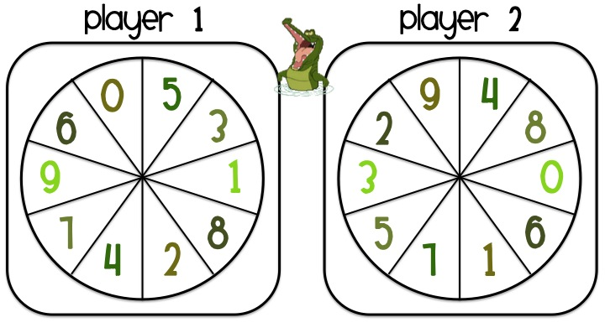

Player 1: _________________________ Player 2: _______________________________
Alligator Spinner

- ________ ________

- ________ ________

- ________ ________

- ________ ________

- ________ ________

- ________ ________

